Smart Flood monitoring Solution

PROGRESS REPORT

IN FULFILMENT OF THE REQUIREMENTS FOR THE COURSE

IoT – CS 532

AT NIIT UNIVERSITY

SUBMITTED BY: PROJECT MENTORS:
AAKASH KODAMASIMHAM PROF. RAM NARAYAN YADAV
A MALLIKA SRI VIDYA PROF. AMITAVA MUKHERJEE
J SAI HEMANTH
K SACHIN REDDY
M MANOHAR
M PRADYUMNA
M SUPRAJA REDDY
S R RAHUL
T SASI DIAMOND
V VINEEL REDDY
PREVIEW:
- Abstract
- System Model
- Problem Definition
- Contributions
- Review of Literature
- Related Work
- Solution Proposed
- Results of the work completed
- Future work with clear milestones

ABSTRACT:
- This mini project entitles Flood Monitoring System. The purpose of this project is to improve road user safety when occurrence of flash flood. Our target for this project is in those areas that frequently occurrence flash flood especially in coastal areas. Nowadays, the road user will be trapped in flash flood because of the information about flash flood always delay. Now, this project gives road user alternative to provide them from the flash flood. Firstly, the ultrasonic sensor will be placed into the river to detect the level of river water. When the water rate increases, the reading of water level of river will be shown at monitor. If the water level reaches in beyond threshold, the alert is send central management system and also logged in the cloud and website. An email is also sent to the related individual.

SYSTEM MODEL:
- Developing a flood warning system requires attention to three basic factors:
  - Data collection.
  - Data processing.
  - The hardware and software required and the dissemination of flood warning information.

PROBLEM DEFINITION:
- When floods occur many lives near the coastal region are in danger.
- As they travel at a high rate of speed we need to quickly send alert to evacuate a large area near the region.
- We need a long range communication to take care of this.
- We need a real time monitoring system for frequent flood prone regions.

CONTRIBUTIONS:
- Hardware Implementation:
  - A. Mallika. - Ultrasonic Sensor
  - K. Sachin Reddy. - Arduino
  - S. R. Rahul. - LoPy
  - T. Sasi Diamond. - Bluetooth
- Software Implementation:
  - J. Sai Hemanth. – Website Frontend Development
  - M. Manohar. – Website Frontend Development
  - M. Supraja Reddy – Data Acquisition and Email generation.
  - V. Vineel Reddy. - Data Acquisition and Email generation.
  - M. Pradyumna - Website Backend Development
  - K. Akash - Website Backend Development

REVIEW OF LITERATURE:

[1] Elizabeth A. Basha, Sai Ravela and Daniela Rus, “Model-Based Monitoring for Early Warning Flood Detection”, SenSys’08, November 5–7, 2008, Raleigh, North Carolina, USA. Copyright 2008 ACM 978-1-59593-990-6/08/11.
[2] Edward N. Udo and Etebong B. Isong, “Flood Monitoring and Detection System using Wireless Sensor Network”, ASIAN JOURNAL OF COMPUTER AND INFORMATION SYSTEMS (ISSN: 2321 – 5658).
[3] Sheikh Izzal Azid and Bibhya Nand Sharma, “SMS BASED FLOOD LEVEL MONITORING SYSTEM”, Faculty of Science Technology and Environment, The University of South Pacific Suva Fiji.
[4] Shifeng Fang; Li Da Xu; Yunqiang Zhu; Jiaerheng Ahati; Huan Pei; Jianwu Yan; Zhihui Liu, “An Integrated System for Regional Environmental Monitoring and Management Based on Internet of Things”, IEEE Transactions on Industrial Informatics ( Volume: 10, Issue: 2, May 2014 )
[5] J C Pagatpat1 , AC Arellano and OJ Gerasta, “GSM &web-based flood monitoring system”, 1st International Conference in Applied Physics and Materials Science.

RELATED WORK:

- From digital Earth to smart Earth
– S.R.Rahul
Related Work:
This article summarizes the achievements of digital Earth, and introduces the inevitable trend from digital Earth to smart Earth. They believe that digital Earth combined with IOT and cloud computing can evolve to be a smart Earth, that supports participation and communication between human beings, human-machines and machine–machine to provide IOT oriented intelligent services. They designed an architecture of smart Earth and introduced typical applications based on smart Earth. They further examined the developing prospects from digital Earth to smart Earth. They consider that digital Earth belongs to cyber space, and smart Earth belongs to cyber physical space. It must be noted that to achieve a smart Earth, key technical and nontechnical issues need to be solved such as automatic data collection, reliable information transmission, real-time information processing, and personal privacy protection.
- Digital Earth and the achievement:
Multiresolution and multi tense observation and analysis of Earth:
Digital Earth is an important method for scientists, especially geographers, to study the Earth and the environment. Geotectonic, including the diastrophism of the Earth’s surface and geological phenomenon (including earthquake prediction, weather and disaster forecasting, disaster prevention and control, dynamic land monitoring, and resource investigation and environmental protection) can be understood by digital Earth.
Method | Place | Based on
Dynamic monitor demonstration of unlicensed building detection. | Beijing | Remote Sensing  Change Detection

Visualization and scalability of graph-based and real image-based spatial world integration:
An image-based 3D real-life scenery model may establish a large area seamless stereo Orth image with real-life scenery along the street, which could be used in visualization and a ‘‘survey on demand’’. It provides high-resolution data, full element information and image data with centimeter resolution for public security, municipal administration, transportation, navigation and location-based services (LBS). This kind of ‘‘visible, measurable, mineable’’ close range image data (namely real-life scenery images) when fused with the web-based electronic map products, make it possible to build an ‘‘image Earth’’ with Orth image and real-life scenery images as the main shared data pool.
Algorithm | Functions
Stereogram Forward Intersection Algorithm | Integrating Digital Elevation Model (DEM), Digital Measurable Image (DMI), and Digital Line Graph (DLG).

Web service-based spatial information sharing and intelligent service:
In the field of geo-spatial information, using web service technology can register various spatial information resources and provide online services. These include geospatial information resource registration services, sensor services, spatial information transmission services, spatial data services, spatial information processing services, and spatial information visualization services.
Software | Developer
Web Service Technology based Aggregation of the Processing Software | National Aeronautics and Space Administration (NASA)
State Key Laboratory of Information Engineering in Surveying, Mapping, and Remote Sensing (LIESMARS) | Not Specified

- The emergence and development of sensor web and IOT:
A sensor web is a controlled system linked by a certain number of sensor nodes through a wired or wireless communication protocol. These nodes are constituted by sensing, data processing, and communication functional modules. The sensor nodes are usually small in size, low cost, low power, and multifunctional. The biggest difference between a sensor web and computer networks is that a sensor web node is determined by the spatial location and sensor type, while an ordinary computer network node is only determined by its unique identifier. At the end of the sensor node, it incorporates analog signal conditioning, digital signal processing, and network communications capabilities; and a node has self-testing functionality.
Sensors | Source
Thermostats | http://www.roboshop.in/sensors
Pressure Gauges | http://www.roboshop.in/sensors
Pollution Detectors | http://www.roboshop.in/sensors
Cameras | http://www.roboshop.in/sensors
Microphones | http://www.roboshop.in/sensors
Glucose Sensors | http://www.roboshop.in/sensors
EKGs | http://www.roboshop.in/sensors
Infrared Sensors | http://www.roboshop.in/sensors
GPS | http://www.roboshop.in/sensors
Laser Scanners | http://www.roboshop.in/sensors
Sensor Specification Not specified in the paper.
- Cloud computing and its application:
In the near future, the projected seven trillion sensing devices will be collecting data for users every minute or possibly even every second. Most of these data require real-time processing and analysis in order to provide immediate information and services, such as traffic conditions, flow density, and location. Because of the huge number of sensing devices, and the individual demands for services, service providers must provide a large enough pool of resources and sufficient mechanisms for flexibility.

Application | Description | Source
Tianditu, also known as ‘‘Map World’ | It is a website providing ‘‘one stop’’ geospatial information services to the personal users, enterprises, professional agencies, and governments via public networks such as the internet, and the mobile communication network. | http://www.tianditu.cn
OpenRS-Cloud | It achieves dynamic monitoring and task allocation of data and computing resources in the internet environment by using an open platform architecture design. It ultimately forms an extensible, scalable, configurable, and customizable framework for processing utilizing remote-sensing images. | http://www.openrs.org/wiki/

- An overview of Smart Earth:
Remote-sensing, GIS, and network technology connected with social sustainable development on a digital Earth provides a basic framework for globe information. IOT is a network with intelligent recognition, positioning, tracking, monitoring, and management through information exchange and communication. It connects all things with the internet through intelligent sensor networks. Mass data storage, real-time computing, and interactive services are solved by a cloud computing platform, while the results of cloud computing can be used for automatic control of various facilities by intelligent control networks. We can realize the smart Earth from digital Earth by combining IOT and cloud computing.

- Design of a WSN Platform for Long-Term Environmental Monitoring for IoT Applications
-SASI DIAMOND T
Wireless sensor networks (WSN) are well suited for long-term environmental data acquisition for IoT representation. This paper presents the functional design and implementation of a complete WSN platform that can be used for a range of long-term environmental monitoring IoT applications.
It was aimed to complement human-entered data that was seen as a limiting factor to acquisition accuracy, pervasiveness and cost.
Two technologies were traditionally considered key enablers for the IoT paradigm:
- The radio-frequency identification (RFID) and
- The wireless sensor networks (WSN).
This paper presents the application requirements, the exploration of possible solutions, and the practical realization of a full-custom, reusable WSN platform suitable for use in low-cost long-term IoT environmental monitoring applications.
For a consistent design, the main application requirements for
- low-cost,
- fast-deployment of large number of sensors, and reliable and long unattended service
- Also, the platform requirements of flexibility and reusability for a broad range of related applications was considered from the start
- Finally, the experimental results show that the platform implementation satisfies the specifications.
The rest of the paper is organized as follows.
Section II reviews published works addressing similar topics.
e.g., chemical hazard, earthquake and flooding detection, volcano and habitat monitoring, weather forecasting, precision agriculture, for traffic, lighting or pollution monitoring)
Section III defines a comprehensive specification set for WSNs for IoT environmental monitoring applications.
For a fast response time, the coverage of even small areas requires a large number of sensor nodes, making this application representative for cost, networking and deployment issues of the event-driven high-density IoT application class.
In the simplest star topology, the sensor nodes connect directly to the gateways, and each gateway autonomously connects to the server. Ideally, the field deployment procedure ensures that each sensor node is received by more than one gateway to avoid single points of failure of the network.
This application can be part of all three WSN categories
- Event - driven
- Time - driven and
- Query driven
This means that the infrastructure that supports the operation of this application can be reused for a wide class of similar long-term environmental monitoring applications like:
- water level for lakes, streams, sewages;
- gas concentration in air for cities, laboratories, deposits;
- soil humidity and other characteristics;
- inclination for static structures (e.g., bridges, dams);
- position changes for, e.g., landslides;
- lighting conditions either as part of a combined sensing or standalone, e.g., to detect intrusions in dark places;
- Infrared radiation for heat (fire) or animal detection.
Section IV summarizes the structure and the main functions of a WSN platform for these applications.

The tiered structure of the used platform was introduced by one of the first long-term outdoor WSN experiments and allows:
_ a good functional separation of platform components for optimization according to application requirements;
_ a cloud-based field data access to bridge the latency energy trade-offs of the low power communication segments and the ubiquitous and fast access to field data for end users (either humans or IoT applications).
In addition to the elements described above, the platform can include an installer device to assist the field operators to find a suitable installation place for the platform nodes, reducing the deployment cost and errors.

Section V details the specifications and design solutions for the WSN nodes and field deployment devices.

The sensor node energy consumption can be divided into:
_ RF communication, for data and network maintenance;
_ processing, e.g., transducer data, self-checks, RTC;
_ sensing, e.g., transducer supply, calibration;
_ Safety devices, e.g., watchdog timer, brown-out detector;
_ Power down energy required by the node components in their lowest power consumption mode.

Section VI presents the practical realization and operation of the WSN nodes and the field deployment devices.
Section VII presents the application server design, structure and operation.

The main purpose of a WSN application server is to receive, store, and provide access to field data. It bridges the low power communication segments, with latency-energy trade-offs, and the fast and ubiquitous end user field data access (by humans or IoT applications).
The full custom server software has the structure shown in
It provides interfaces for:
_ field nodes (gateways);
_ the operators and supervisors for each field;
_ various alert channels;
_ external access for other IoT systems.
Section VIII presents an effective sensor node field deployment procedure.
Section IX concludes the paper.
A real-life, demanding application is selected as reference to guide most of node and platform solution exploration and the implementation decisions.All aspects of the WSN platform are considered: platform structure, flexibility and reusability, optimization of the sensor and gateway nodes, optimization of the communication protocols for both in-field and long range, error recovery from communications and node operation, high availability of service at all levels, application server reliability and the interfacing with IoT applications. Of particular importance are IoT requirements for low cost, fast deployment, and long unattended service time. All platform components are implemented and support the operation of a broad range of indoor and outdoor field deployments with several types of nodes built using the generic node platforms presented. This demonstrates the flexibility of the platform.

- GSM and Web Based Monitoring system
    - J. Sai Hemanth

Tools used | Specifications | Vendors
GSM Kit(GSM sim 900 and Arduino Mega 2560,GSM USB Dongle) | GSM module,wireless transmission,To establish TCP communication over the broadly sread GPRS network | https://dir.indiamart.com/impcat/gsm-module.html
GSM Library | Communication between Arduino IDE and GSM Shield | Inbuilt in the Arduin
Water level sensors | To measure the level of the river. | https://www.vegetronix.com/Products/AquaPlumb/
Rain Guage | When the level of water droplets in the rain guage increases then there is a detection of change in the level of rain fall volume and will trigger GSM module to send an SMS | http://www.urjakart.com/weather/weather-meters/rain-gauges

Related work:
The water level detector is placed with a GSM kit that sends signal to the sever node if the system detected the alert message then it sends the warning status to the individual subscriber. They have the privilege to know the water level of the particular area by typing the specific keyword which directs the details to the specific node. But the monitoring device uploads the data continuously on the website providing more access to the users. The practical tests conducted are said to be reliable for the users and the wireless communication is also good. The data used in the website can be refreshed as per our specifications i.e., for every 12 hours or 1 day and so on Ajax. Project NOAH by the department of the Science and Technology gave this paper a good start. The computer can also post the Alerts on the social media and twitter etc.

- MODEL-BASED MONITORING FOR EARLY WARNING FLOOD DETECTION
    - Aakash K
Current Model:
- It rely on volunteers and limited technology. Volunteers read the river level oﬀ of markings painted on bridges and the rain level from water collecting gages at several intervals during a day.
- Records the values in a book, and compares them to a deﬁned policy whereby the river level measured corresponds to a color alert.
- Which then decides on the need for an evacuation alert in that region and implements some form of emergency alert procedures.
- Relies on very little technology and extensive policies to warn communities.
Prediction Model:
- Algorithm requires rainfall, air temperature, and water ﬂow data collected and transmitted in real-time over the entire river basin area multiple times per hour.
- Since the ﬂow of a river may change signiﬁcantly over a period of several minutes, this suggest a sampling rate on the order of minutes.
- In order to support distributed, robust, real-time data collection, transmission, and, eventually, processing for large geographic regions corresponding to real river basins, with some deﬁned system requirements.

- FLOOD MONITORING AND DETECTION SYSTEM USING WIRELESS SENSOR NETWORK
    - K. Sachin Reddy
- The Flood Monitoring and Detection System (FMDS) uses a ZigBee radio which uses ZigBee/IEEE 802.15.4 standard which is the only standard-based technology designed to address the unique needs of low-cost, low-power wireless and control networks.
- The sensors - Temperature, Rainfall, Humidity and Water Level sensors capture signals (data) and send them to the microcontroller (PIC24).
- The data sent is analog in nature, which is digitalized by Analog-Digital converter the microcontroller integrates.
- The Zigbee module sends the information it receives from its radio to the microcontroller for processing.
- The microcontroller can also send packets received from the sensors to the Zigbee module so that it can be radiated and received by other nodes.
- The main objective of the proposed system is to be able to read the water level at every second, display it to the supervisor and alert the affected populace and relevant authorities by means of an alarm and short message system (SMS) when the level of water surpasses a user defined threshold.
- Global System for Mobile Communications (GSM) network has been used for sending the mobile messages.
- Peripheral Interface Controller (PIC) microprocessor is used to read in the input from the sensor and then display the result.
- The measuring system is based upon the theory of pressure being applied to liquids.
- Furthermore, the collated data is useful to the meteorologist for investigating and monitoring the cause of flooding with respect to time and weather patterns.
SOLUTION PROPOSED:
- We used an Arduino microcontroller and LoPy module to interface the sensors and communication protocols.
- We used an ultrasonic sensor to know whether the water is approaching beyond the threshold level.
- If crossed the value, it sends a message to the LoPy module using a BLE module.
- As LoPy is a Long Range communication module, it immediately sends this message to the Central Management System (LoPy) using LoRa protocol.
- An immediate action can be taken and the surrounding region can be evacuated.
ALGORITHM:
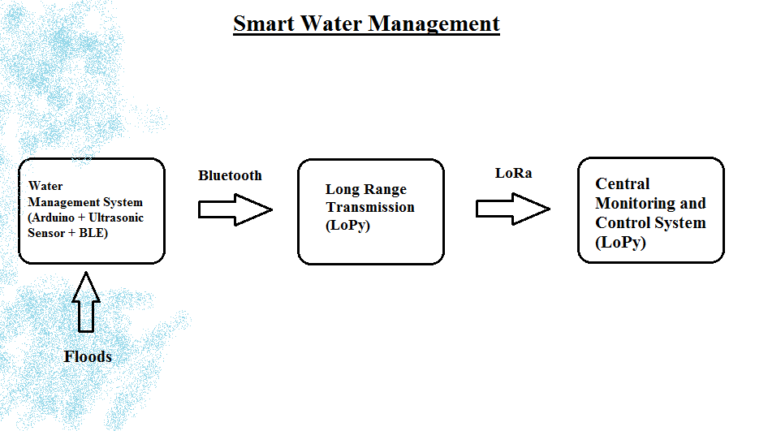
RESULTS OF THE WORK COMPLETED:
ULTRASONIC SENSOR:
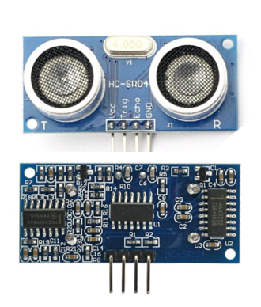
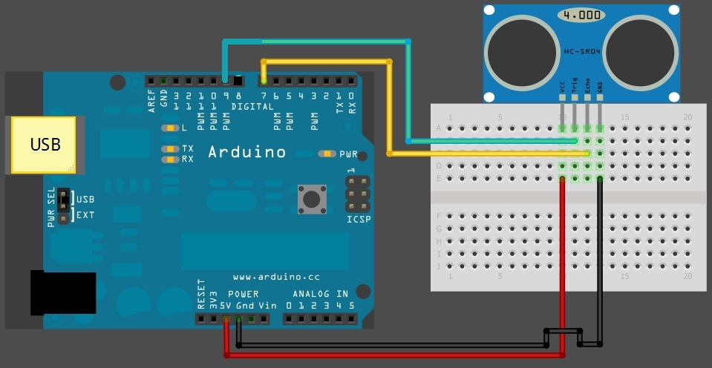
BLUETOOTH:
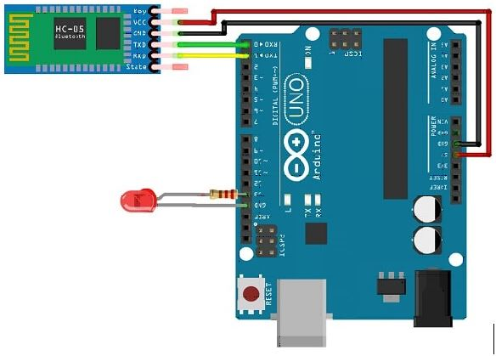
SENSOR OUTPUT:
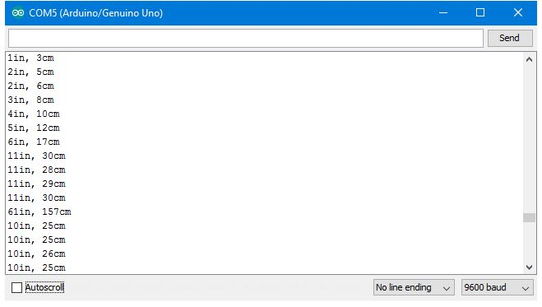

PYMAKR OUTPUT:
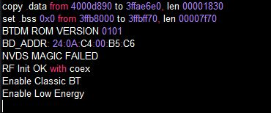

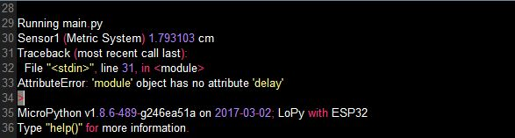

THINGSPEAK CLOUD:
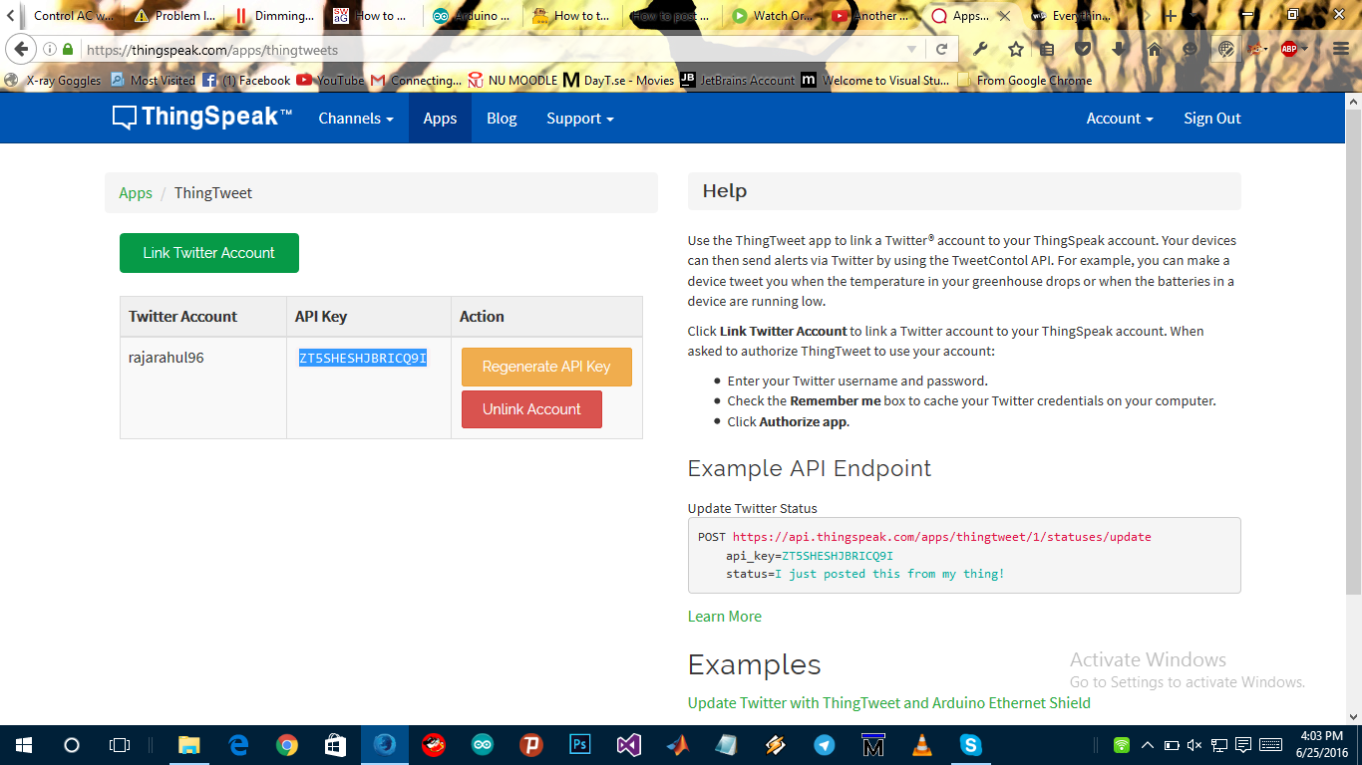

THING HTTP:

MAIL:
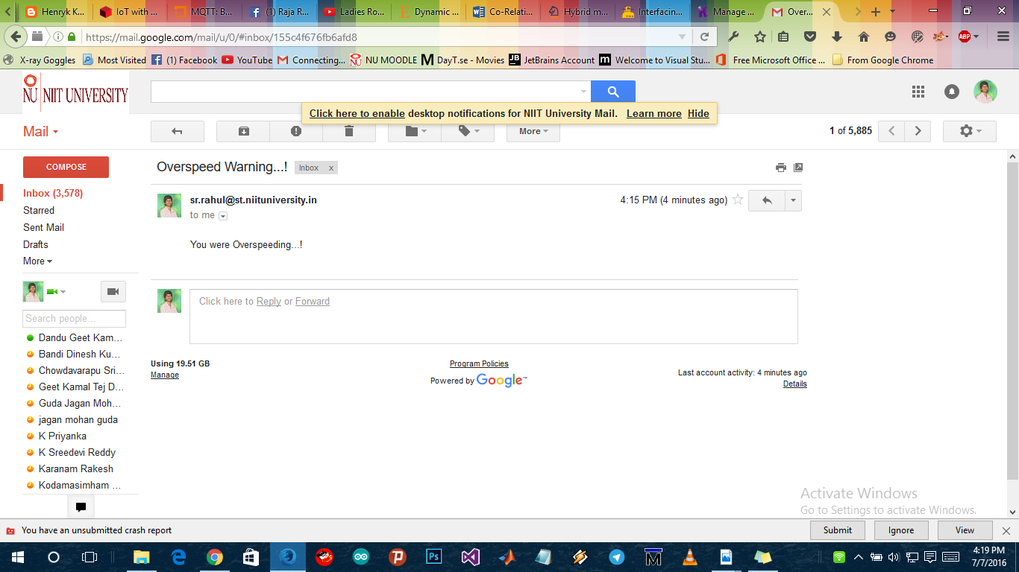
CENTRAL MONITORING WEBSITE:
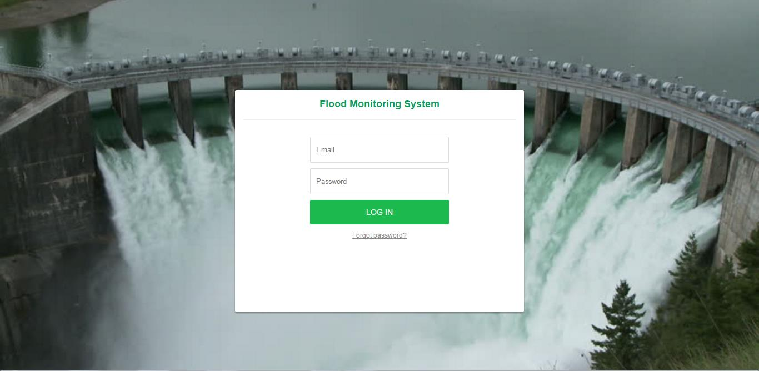

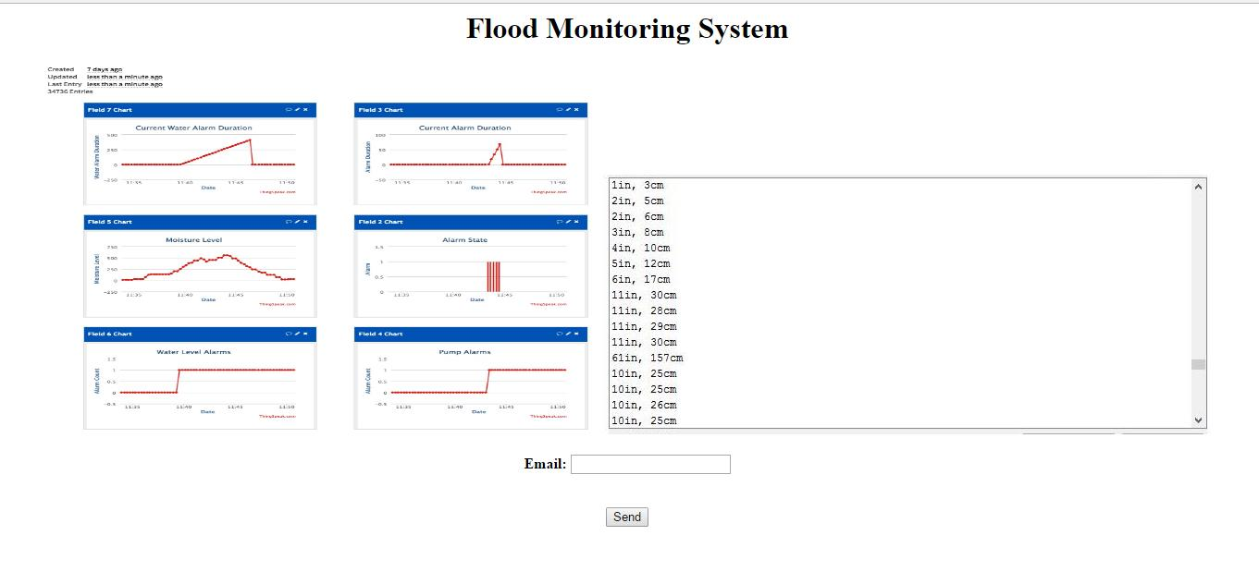
CONCLUSION AND FUTURE WORK:
- Till today, there is very little work done in the area of LoRa. So, we adopted Lora protocol for our project and we have done our best to make a more reliable flood management system.
- We have done Flood detection, monitoring and control system.
- We are working on implementation of Floods Prediction algorithms.

